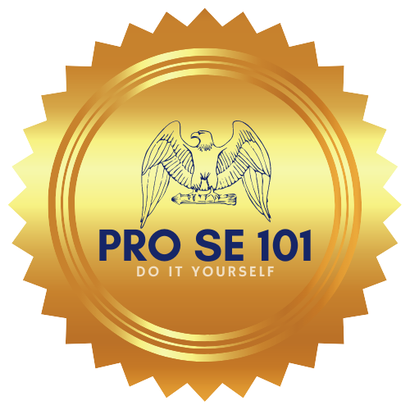

This is a do it yourself process, by filling out this questionnaire you are filling out your court ready Child or Children’s Vaccination Exemption. We are not a law firm or attorneys, we do not give legal advice, file documents, or aid in any way besides preparing your Child or Children’s Vaccination Exemption documents using your answers from our questionnaire.

Questionnaire For Child or Children’s Vaccination Exemption

1. Name of Child or Children needing exemption:

_______________________________.

_______________________________.

_______________________________.

_______________________________.

_______________________________.

2. Parent Name, Phone Number and address: __________________________________________________________________________________________________________________________________________________________________________________________

3. Your Email Address: ___________________________
4.. Reason for wanting a Vaccination Exemption: _____________________________________________________________________________________________________________________________________________________________________________________________________________________

