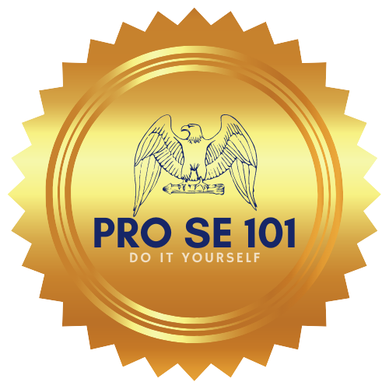

This is a do it yourself process, by filling out this questionnaire you are filling out your Vaccination Exemption. It is your right to either take a vaccine or not, we are here to help you do just that. We are not a law firm or attorneys, we do not give legal advice, file documents, or aid in any way besides preparing your court ready Vaccination Exemption documents.

Questionnaire For Adult Vaccination Exemption

1. Name of Person needing exemption:

_______________________________.

2. Address of person needing Exemption: ____________________________________________________________________________________________________________________________

3. Phone Number of person needing Exemption: _______________________________________

4. Reason for wanting Exemption:

________________________________________________________________________________________________________________________________________________________________________________________________________________________________________________________

5. Place of Employment : ___________________________
6. Email Address: ________________________________

